Rag-Based Multi-Agent platform

## Introduction

Ever since it was first introduced int 2020, RAG (Retrieval Augmented Generation) has become an extremely popular method with which we can expand the knowledge base of our LLMs.

Using this, we can use other sources of information (databases, websites, etc.) in order to supplement existing knowledge and create more personalized answers.

Along with this we aim to us multi- agent systems to create better interactions with the users. Each agent will cater to a different aspect of the user’s needs and will thus create an enriching experience. To achieve this we could either use OpenAI swarm (still in development and is not supported) or crewAI.

## Proposed Structure

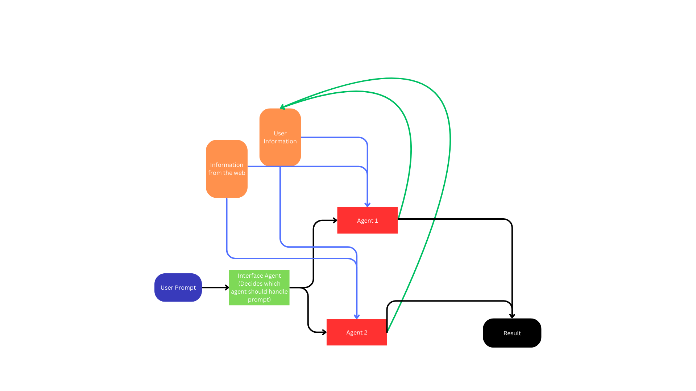

To implement RAG in multiple agents, we can use such a system.

Every time the user sends a prompt, it first goes to an interface agent. Its task is to check the type of prompt and then pass it on to the appropriate agent.

Each agent has a different type of instruction depending on their intended task. Some agents might be handling crucial tasks (like health, finance, etc) and therefore cannot be very creative.

These agents will have two tasks. One will be to generate an appropriate response. For this, it will use its own knowledge base, which will be supplemented with RAG.

Our system will use RAG on two types of data, personal data and web data. Personal data belongs to the user, and will be accumulated while the user uses the app. These could include schedules, health-related information, etc. The other will be generated through web-scraping and searching the internet. Caution must be used for the latter, especially in sensitive areas like finance and healthcare.

# Possible applications

Since the problem statement has given us the liberty to build our own system to showcase RAG based multi-agent system, these are some things which we may explore

* A personal manager which will help monitor all aspects of a person. It can have separate agents managing things like health, finances, schedules, etc.
* A multi-agent user-support system, where each agent is specialized in one particular domain.